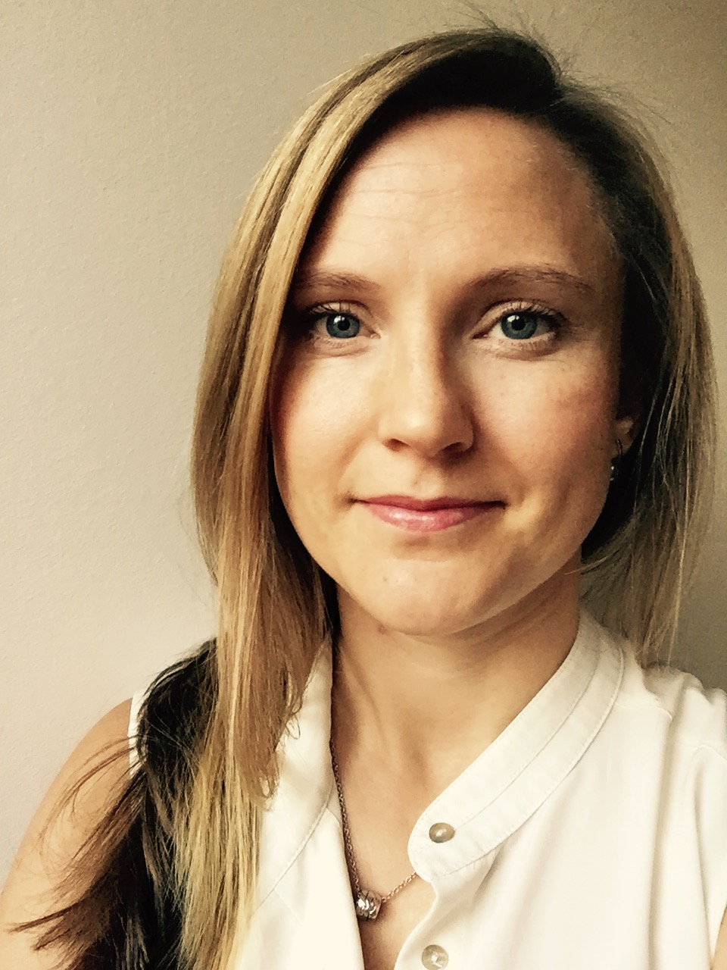
General Practitioner and PhD student. Research topics include methodological aspects when evaluating benefits and harms of screening, informed choice, overdiagnosis/too much medicine and evidence-based medicine.

EDUCATION
2012 – present PhD student University of Gothenburg
2017 Medical statistics II University of Gothenburg (5 credits)
2016 Medical statistics I University of Gothenburg (5 credits)
2015 How to practice evidence-based health care Norwegian Institute of Public Health (1.5 credits)
2014 Scientific communication National Research School for General Practice (4.5 credits)
2002 – 2007 School of Medicine University of Umeå

PROFESSIONAL EXPERIENCE
2017 – present General Practitioner Herrestad HCC, Region Västra Götaland
2010 – 2017 Resident Physician Herrestad HCC, Region Västra Götaland
2008 – 2010 Medical Intern NU hospital group, Region Västra Götaland
1999 – 2002 Care Assistant Karlskrona Municipality, Blekinge

TEACHING
2014 – present Evidence-based medicine, 12 h, Research Methodology in Primary Care (SM00016), PhD course, University of Gothenburg
2016 – present Evidence-based medicine, 9 h, Introduction to research for resident physicians, FoUU centre Fyrbodal, Region Västra Götaland
2016 Evaluation of screening programmes, 2 h, Screening and Prevention in Primary Health Care (43VT11), PhD course, University of Gothenburg

OTHER
2017 – present Member of the Junior Research Committee, Preventing Overdiagnosis conference
2017 – present Chair of the Council for Sustainable Medicine, the Swedish College of General Practice
2015 – 2018 Peer-review for The Lancet
PUBLICATIONS
Peer-reviewed
Original research
- Johansson M, Zahl PH, Siersma V, Jørgensen KJ, Marklund B, Brodersen J. Benefits and harms of screening men for abdominal aortic aneurysm in Sweden - comparing age-matched, contemporary screened and non-screened cohorts in a population with falling incidence. Lancet 2018;391:2441-7.
Analysis papers
- Johansson M, Hansson A, Brodersen J. Estimating overdiagnosis in screening for Abdominal Aortic Aeurysm: could a change in smoking habits and lowered aortic diameter tip the balance of AAA screening towards harm? BMJ 2015;350:h825.
- Johansson M, Jørgensen KJ, Getz L, Moynihan R. Informed choice in a time of too much medicine – no panacea for ethical difficulties. BMJ 2016;353:i2230.
Systematic Reviews
- Johansson M, Brodersen J, Gøtzsche P, Jørgensen KJ. Screening for reducing morbidity and mortality in malignant melanoma (Protocol). Cochrane Database of Systematic Reviews 2016, Issue 9. Art No.:CD012352.
Comments
- Johansson M, Brodersen J. Informed choice in screening needs more than information. Lancet 2015;385:1597-9.
- Johansson M, Harris RP. Thresholds in women with abdominal aortic aneurysm. Lancet 2017;389:2446-8.
- Johansson M, Jørgensen KJ. Should we screen women for abdominal aortic aneurysm? – No. Lancet 2018 (In Press).
Opinion pieces
- Johansson M, Jørgensen KJ, Brodersen J. Harms of screening for abdominal aortic aneurysm: is there more to life than a 0⋅46% disease-specific mortality reduction? Lancet 2016;387:308-10.
Manuscripts submitted for publication
- Johansson M, Brodersen J, Gøtzsche P, Jørgensen KJ. Screening for reducing morbidity and mortality in malignant melanoma. (Systematic Review)
Non peer-reviewed (by selection)
- Johansson M, Jørgensen KJ, Brodersen J. The benefits of screening – and its harms. Lancet 2016;388:563-4.
- Johansson M, Jørgensen KJ, Getz L, Moynihan R. Author´s reply to Timms and Bird. BMJ 2016;354:i4362.
- Jørgensen KJ, Johansson M. Drawing conclusions from the VIVA trial. Lancet 2018;391:1849.

CONFERENCES
2017 Cochrane Colloquium, Cape Town, South Africa
Poster “Including non-randomised studies or letting them go unchallenged?”
The Guideline Challenge, Oxford, United Kingdom
Oral presentation “Informed choice – bringing values into guidelines or fake fix?”
Preventing Overdiagnosis, Quebec, Canada
Oral presentation “Screening for malignant melanoma – a Cochrane review”
Nordic Congress for General Practice, Reykjavik, Iceland
Workshop “Guidelines - should GPs take the lead?” (pre-congress)
Workshop “Overdiagnosis – challenges and opportunities in Sweden”
Workshop “Guidelines – improving medicine or hiding uncertainty?”
2016 WONCA Europe, Copenhagen, Denmark
Symposium “Informed choice – in whose favour?”
Symposium “Harms of screening for life-threatening diseases”
Preventing Overdiagnosis, Barcelona, Spain
Oral presentation “Informed choice in a time of too much medicine”
Oral presentation “Methodological challenges when estimating overdiagnosis in screening for abdominal aortic aneurysm when incidence is falling”
2015 Nordic Congress for General Practice, Gothenburg, Sweden
Symposium “The healthy individual in preventive medicine”
2013 Preventing Overdiagnosis, Boston, USA
Symposium “Assessing the harms of screening”
Nordic Congress for General Practice, Tampere, Finland
Symposium “Benefits and harms of screening”

LANGUAGE SKILLS
Swedish – fluent
English – fluent

